PRESS KIT

NANCY A. HUGHES
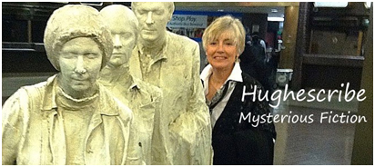
Contact Nancy: www.hughescribe.com. “Contact” tab for email connection
Her publisher: Black Opal Books: editor@blackopalbooks.com sales@blackopalbooks.com. customerservice@blackopalbooks.com.

ABOUT THE AUTHOR

Short Bio
Nancy A. Hughes writes character-driven crime solving mysteries. A Penn State graduate, she followed her dream from journalistic business writing to a life of crime—fiction, that is. The Dying Hour, her debut novel, was published in 2016. Her Trust series followed: A Matter of Trust, and Redeeming Trust, both in 2017, and Vanished: A Trust Mystery, in 2018. The Innocent Hour, the sequel to The Dying Hour, was released on November 16, 2019.
Her mystery novels were published by Black Opal Books. She and her husband live in southeast Pennsylvania.
Longer Bio
Nancy A. Hughes writes character-driven crime solving mysteries. A Penn State graduate, she followed her dream from journalistic business writing to a life of crime—fiction, that is. The Dying Hour, her debut novel, was published in 2016, Her Trust series followed: A Matter of Trust, and Redeeming Trust, both in 2017, and Vanished: A Trust Mystery, in 2018. The Innocent Hour, the sequel to her debut novel, The Dying Hour, was released in November, 2019.
A native of Key West, Nancy and her husband live in southeast Pennsylvania. When Nancy isn’t writing, she is devoted to shade gardening, volunteering at the Reading Hospital and the Lebanon Veterans Hospital. The latter experiences lent authenticity to the setting for The Dying Hour.
She is an active member of the Mystery Writers of America (MWA), International Thriller Writers (ITW), Sisters in Crime (SinC), and Pennwriters. The is a multi-genre authors’ organization of Pennsylvania writers.
Follow Nancy on her website: www.hughescribe.com.
Social Media
Facebook: facebook.com/hughescribe1
Twitter: twitter.com/hughescribe1
Pinterest: pinterest.com/nancy-a-hughes-novels
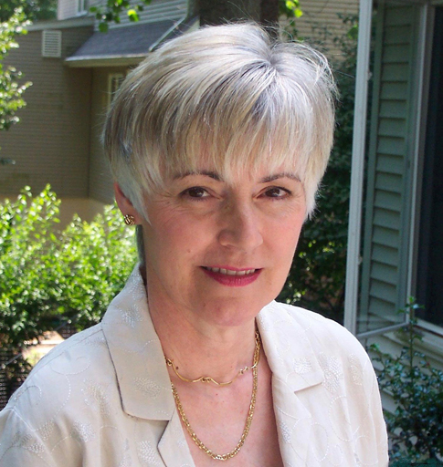
Headshots (Contact Nancy for specific need or required resolution)
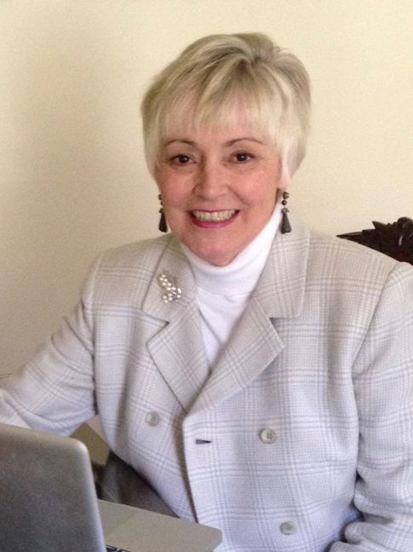

Nancy A. Hughes

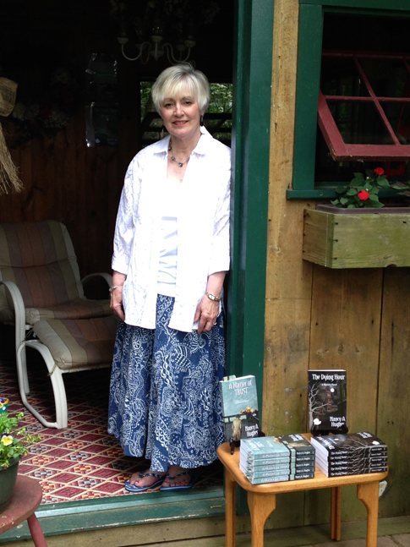
Nancy A. Hughes

Nancy A. Hughes
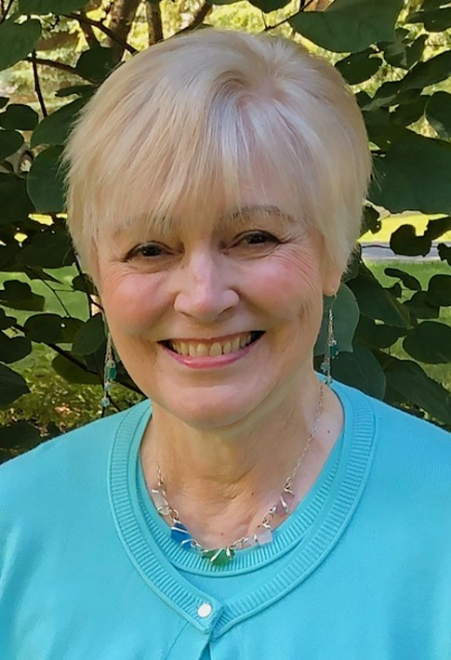
Headshots (Contact Nancy for specific need or required resolution)
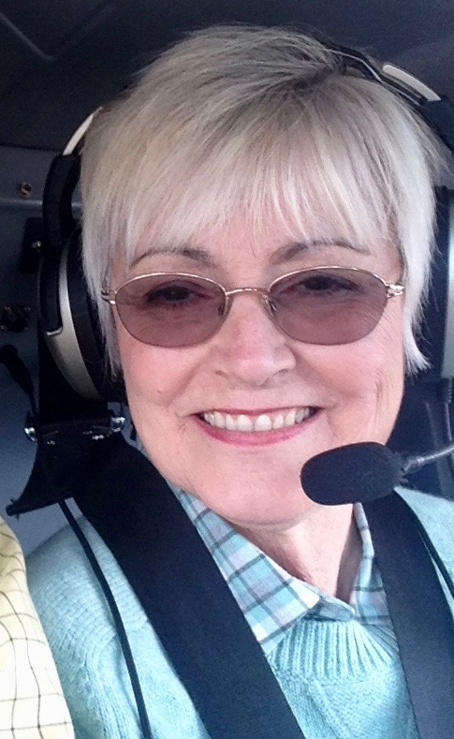

Nancy A. Hughes Nancy A. Hughes

Novels by Nancy A. Hughes

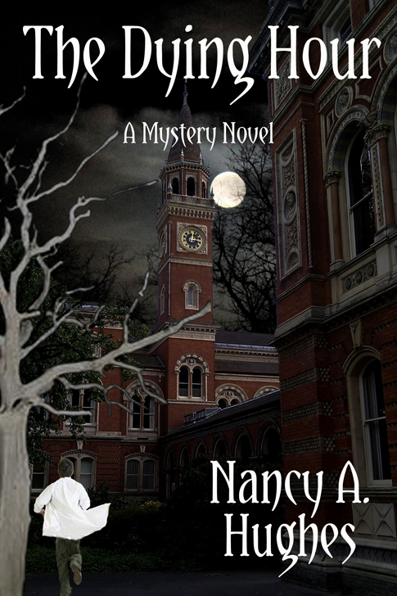

The Dying Hour
ISBN 978-162-694-5432 (print) and 978-162-694-5425 (ebook) Pages: 290, Black Opal Books, October 2016
http://hughescribe.com/books/the-dying-hour
…combines a heart-warming story of family pride and honor with a suspense-filled murder mystery… Taylor Jones Reviewer
Five stars reader comments: “Loved this book.” “This author keeps you reading , reading, reading can't turn the pages fast enough.”
“The intrigue is awesome. Love the main character Charlie. Love to read more with Charlie actually. Also read the Innocent Hour by this author, an equally incredible reads. “Suspense and Mystery in an interesting setting,”
“Strange Happenings at the VA Hospital,” “Very Suspenseful,” “Character and relationships emphasized.”

Novels by Nancy A. Hughes

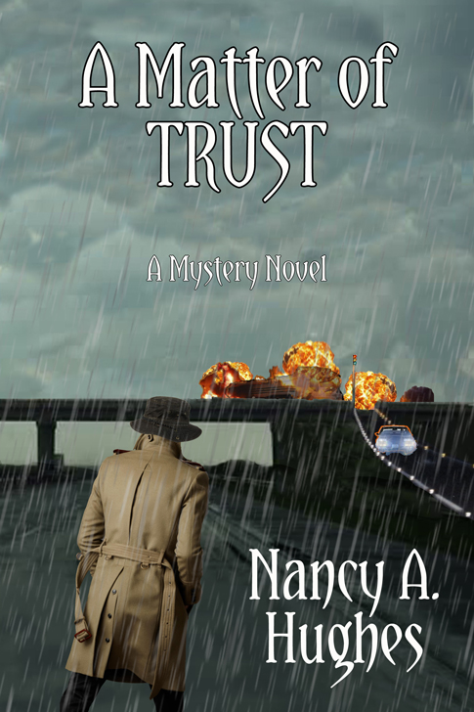

A Matter of Trust
ISBN 978-1-6269436-63-7 Pages: 324, Black Opal Books, May, 2017
http://hughescribe.com/books/a-matter-of-trust
“Hughes blends the subplots so that you can’t tell which thread was related to which crime a she skillfully mixes romance, suspense, and mystery into one cohesive story.” Taylor Jones, The Review Team of Taylor Jones & Regan Murphy.”
Five stars from readers: “Read it! Great summer read at the bay.” “Grabbed my attention immediately. Had a hard time putting it down.” “Hughes is a great story teller. I found this book hard to put down, except to make sure the doors and windows were locked.”

Novels by Nancy A. Hughes

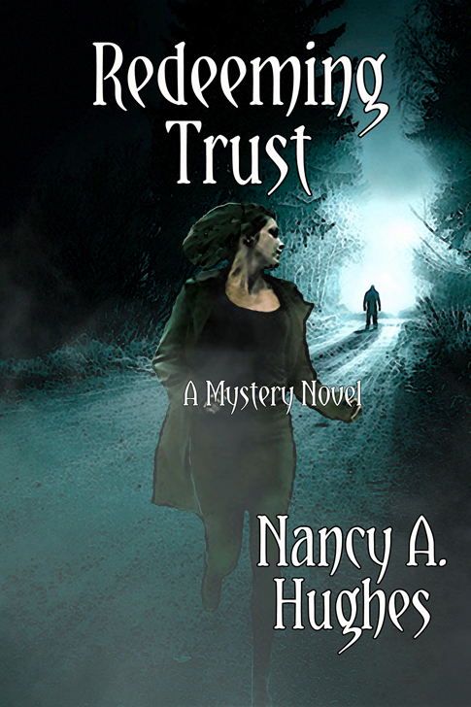

Redeeming Trust
ISBN 978-1-626948-23-5 (print) and in ebook format) Pages: 367, Black Opal Books, December 2019
http://hughescribe.com/books/redeeming-trust
“As usual, Hughes has crafted an exciting mystery that is both moving and compelling, combining great characters, suspense, and intrigue, with a hint of romance. Taylor Jones.
Five star reader reviews: “Nancy Hughes' Trust trilogy, of which this is the second book, is definitely worth reading. Believable characters, unexpected plot twists, and surprising outcomes all contribute to a delightful mystery experience! I love how you get to know the characters well (and the story lines intertwine) throughout Hughes' trilogy. Don't miss reading this book, but read A Matter of Trust first and then Vanished- A Trust Mystery-Book 3!” – DBMBooklady
.“Loved all of Ms Hughes books. Looking forward to the next one.”

Novels by Nancy A. Hughes

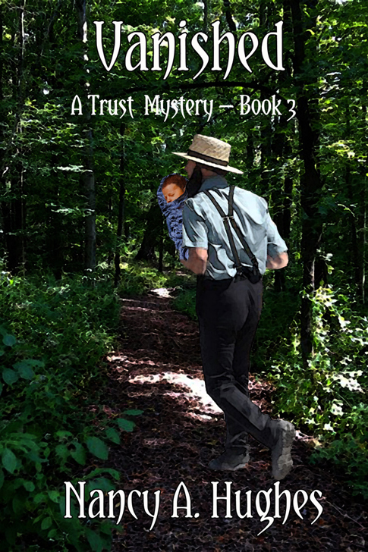

Vanished: A Trust Mystery
ISBN 978-1-644370-01-8 Pages: 329, Black Opal Books,
October 2018 http://hughescribe.com/books/vanished
"An Engrossing read that's built around a chilling premise."--Kirkus Reviews. Read the entire review here: Reviews by Kirkus
5.0 out of 5 stars “Nancy A. Hughes's VANISHED is mesmerizing. It's scary. Imagine your infant being kidnapped and the police accusing you of doing it. The characters range from loveable to horrible. Along the way, the reader flies in a private plane, no less, from coast to coast in search of the baby.”
5.0 out of 5 stars Gets your attention
“Nancy does not disappoint with this interesting plot twist. This is as good, if not better, than her previous books. It seems a life of crime suits her!”

Novels by Nancy A. Hughes

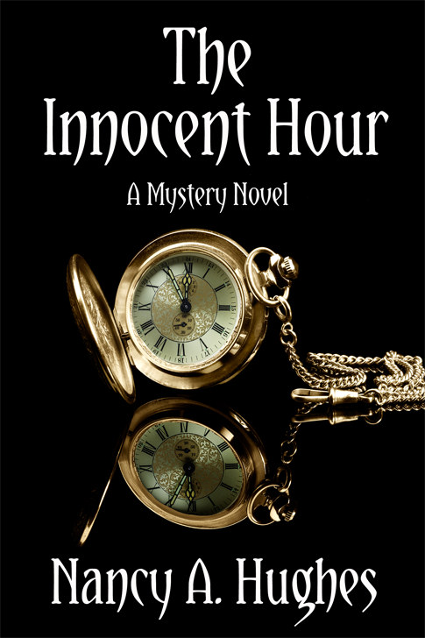

The Innocent Hour
ISBN 978-1-64437-209-8 (print) and 978-64437-208-1 (ebook)
Pages: 301, Black Opal Books, November 16, 2019. http://hughescribe.com/books/the-innocent-hour.
"A deftly-plotted mystery that hooks the reader with its nail-biting fight for justice. Reluctant hero Charlie Alderfer is a well-defined, sympathetic character. When you're backed into a corner with no place to turn, you would want Charlie on your side." Daniella Bernett, mystery author.

Panel/workshop/speaking topics
• From Manuscript to Publication: How to navigate today’s scary publishing world.
• Writing A Series: It doesn’t have to be murder.
• Nancy A. Hughes: Her personal journey from journalist to crime-fiction novelist
• Bread Cast Upon Water: The blessings of volunteering.
• Mid-course Redirection: Daring to change occupations again—and again!
• The Writing Life
• Creating a world of fictitious events, places, good guys and bad guys.

# # #

